There are 2 ways to execute the program.

1. Directly execute Assignment 1/Program/CS535.exe
2. You can also run in Visual Studio. Open the solution under the root folder, after the VS is opened, in the Solution Explorer, right click ‘CS535’ project and select ‘Set as startup project.’

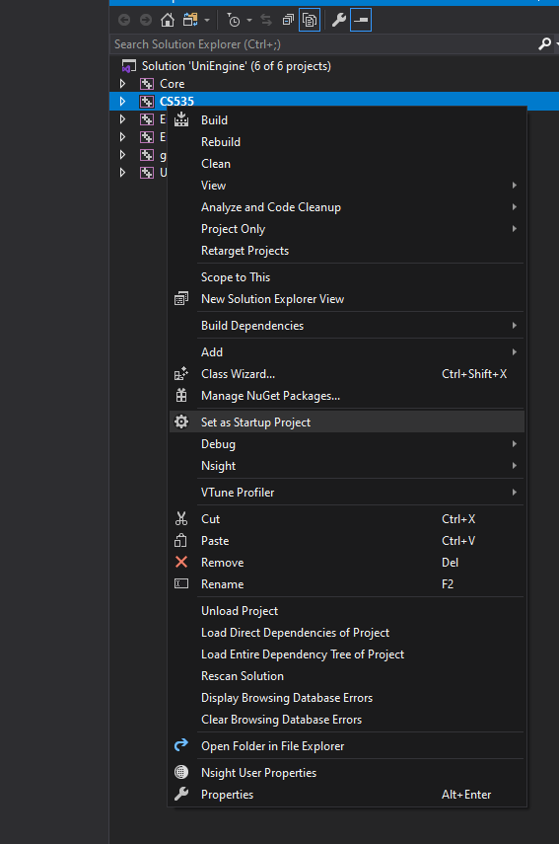

For the first time, you need to rebuild the solution. It does not matter if you want to build with Release & X64 or Debug & X64, both will work.

**Some notes for this assignment:**

I used my own engine for the assignment, and I plan to use my engine for all future assignment for this course. I have sent email to our professor and he agreed with me.

I have used various libraries in the engine, including glm, assimp, ImGui, glfw, stb, etc. However, firstly the engine was solely developed by myself, not a single line of code was write by others, secondly, I will not use any of these library to fulfill the requirement in the project.

Specifically, for this assignment, you can find the source code for vec3, vec4, and mat4 definitions in CS535/Math.h. I only use that for point rotation/transform calculation. You may confirm that in CS535/CS535.cpp.

Once I get the result from my own math library, since the engine depends heavily on glm, I made a conversion from my math objects to glm objects that involves absolutely no calculation. You can find the conversion methods above the main().

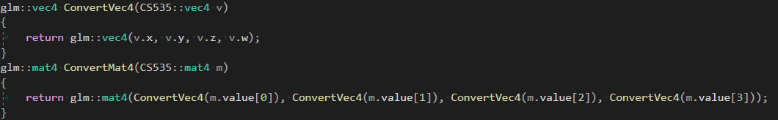

Should you have any questions, please send me an email and I will be happy to reply ASAP.

Thank you,

Bosheng